# **Steps to setup a Hadoop architecture on 3 EC2 instances**

1. Sign on to the AWS account and go to **Dashboard**.



1. Select the **EC2** option and choose the **Instance** tab on the sidebar.



1. Choose the **Launch Instance** tab and Select one Linux AMI option. I am choosing Ubuntu 16.04 for the illustration purpose.



1. Select the **Instance** type as per machine requirement. I am selecting free tier2 micro option.



1. Enter the number of instances as per the requirement of cluster nodes (3 in this case) and select next.



1. Choose the storage capacity according the requirement (30 gb in this case) and go to next page.



1. Give the names to track the instances and select the next.



1. Select the open security for the testing purposes and security rules can be changed later.



1. Review the instance and select launch. Create a new key-pair and give it a name.



1. Go to instances, give name to the instances for the tracking purpose if you have not given at the setup time. Wait for all the status check to be green.



1. Select any instance and refer the connect tab to know the procedure to ssh to the instance. Windows user need to convert “.pem” key to “.ppk” key file. Go to the puttygen, load the key and save the private key.



1. Save all the private ip address and public ip address for your reference.

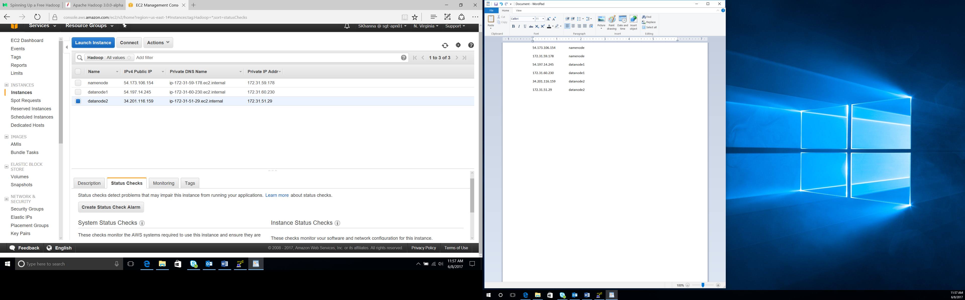

1. Now open putty and connect to the instances using public ip address.

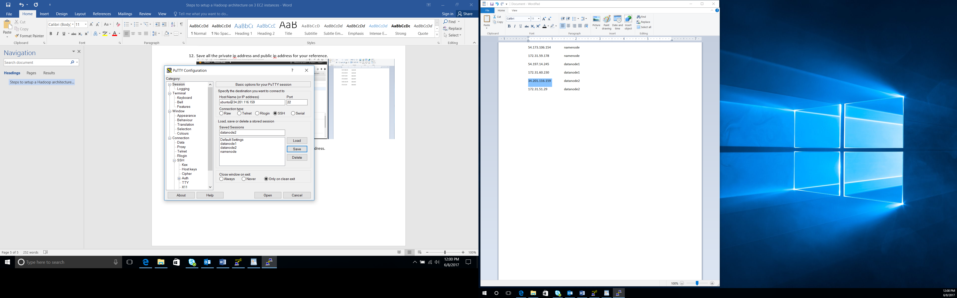

1. After the connections, we have to install the prerequisites.

* Enter the hostnames for easy identification and private ip addresses into the /etc/hosts file of all the instances.

**ubuntu@ip-172-31-59-178:~$ sudo vi /etc/hosts**

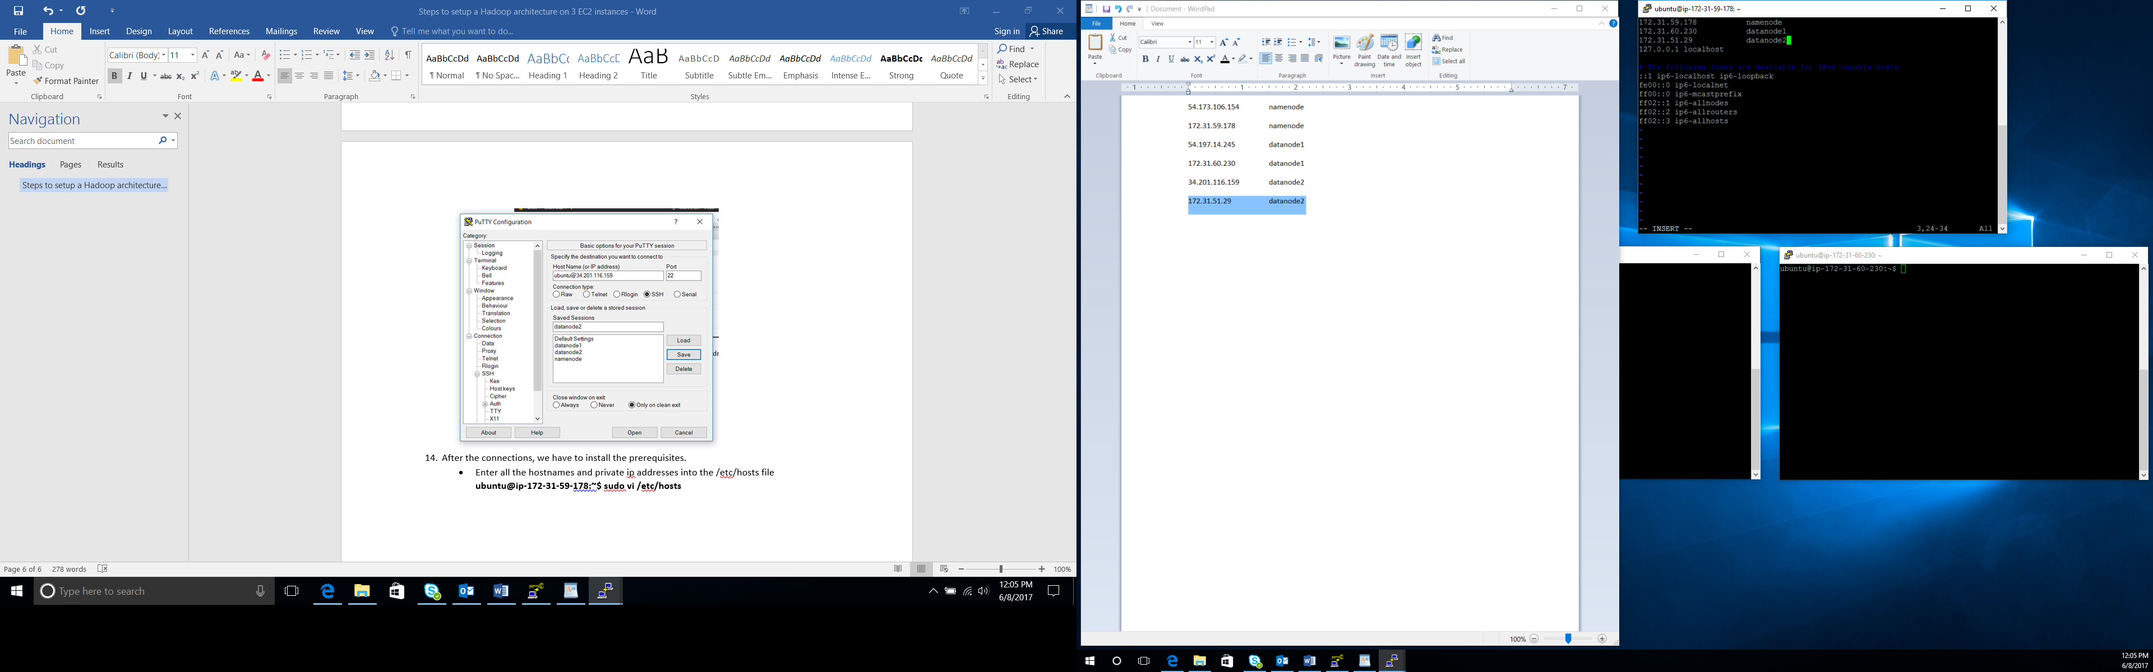

1. Now setup password-less SSH between Namenode and datanodes. Using the following keys in namenode.

**ubuntu@ip-172-31-59-178:~$ ssh-keygen**

press enter while it asks for the names.

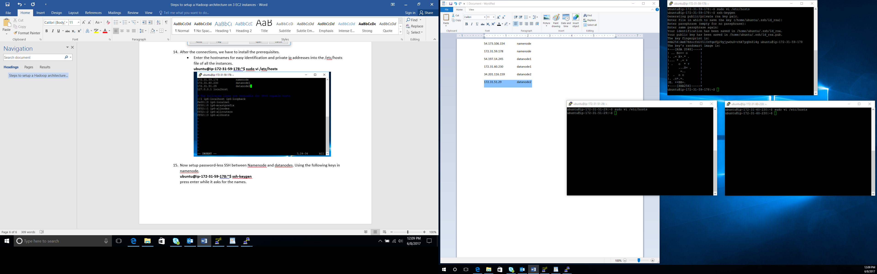

Now copy the public key into the namenode authorized keys and datanodes.

**ubuntu@ip-172-31-59-178:~$ cat ~/.ssh/id_rsa.pub >> ~/.ssh/authorized_keys**

**ubuntu@ip-172-31-59-178:~$ cat ~/.ssh/id_rsa.pub**

After the above command the public key will display on the screen. Copy that key and append it to the datanodes authorized key file.

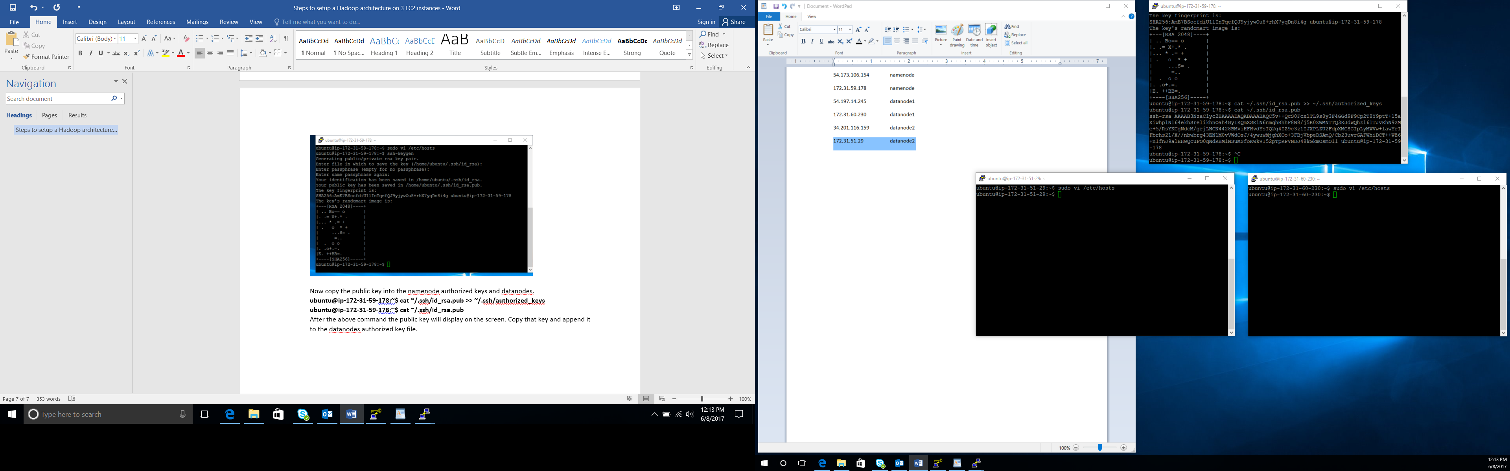

Go to the datanodes. Open the authorized_keys file and copy the above key in the end.

**ubuntu@ip-172-31-51-29:~$ sudo vi ~/.ssh/authorized_keys**

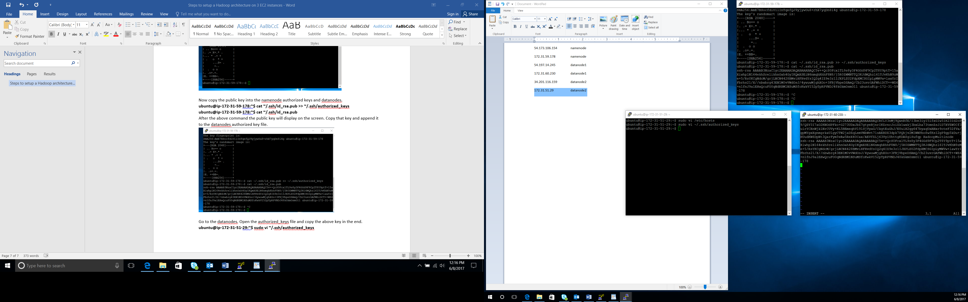

Verify the password-less SSH by using the below commands. First time, the below command will pop for the authorization, enter yes.

**ubuntu@ip-172-31-59-178:~$ ssh localhost**

**ubuntu@ip-172-31-59-178:~$ ssh namenode**

**ubuntu@ip-172-31-59-178:~$ ssh datanode1**

**ubuntu@ip-172-31-59-178:~$ ssh datanode2**

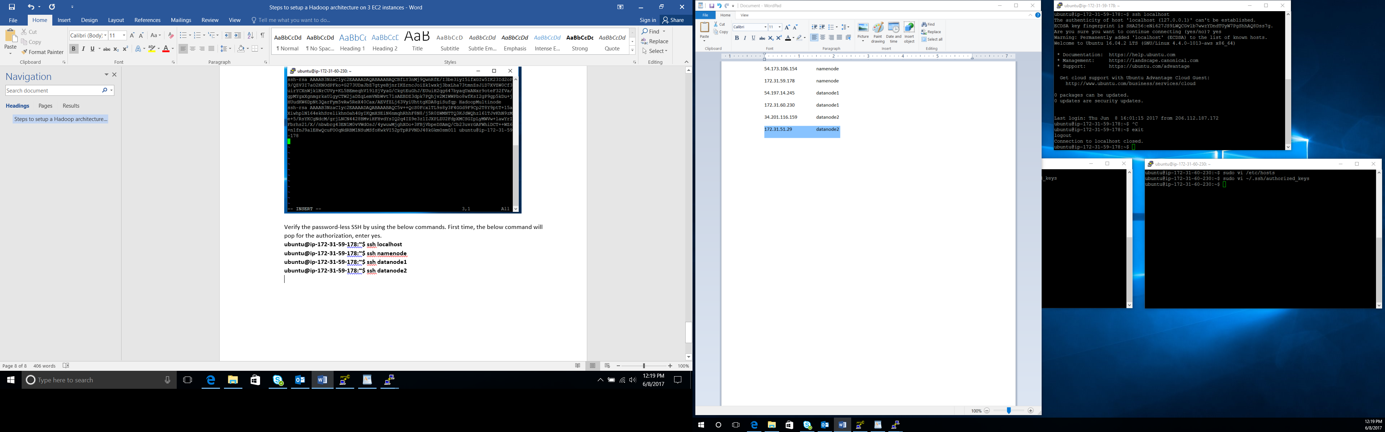

1. Now install Java in all nodes.

**ubuntu@ip-172-31-59-178:~$ sudo apt-get update**

**ubuntu@ip-172-31-59-178:~$ sudo apt-get install openjdk-8-jdk**

**ubuntu@ip-172-31-59-178:~$ java –version**

verify using the above command

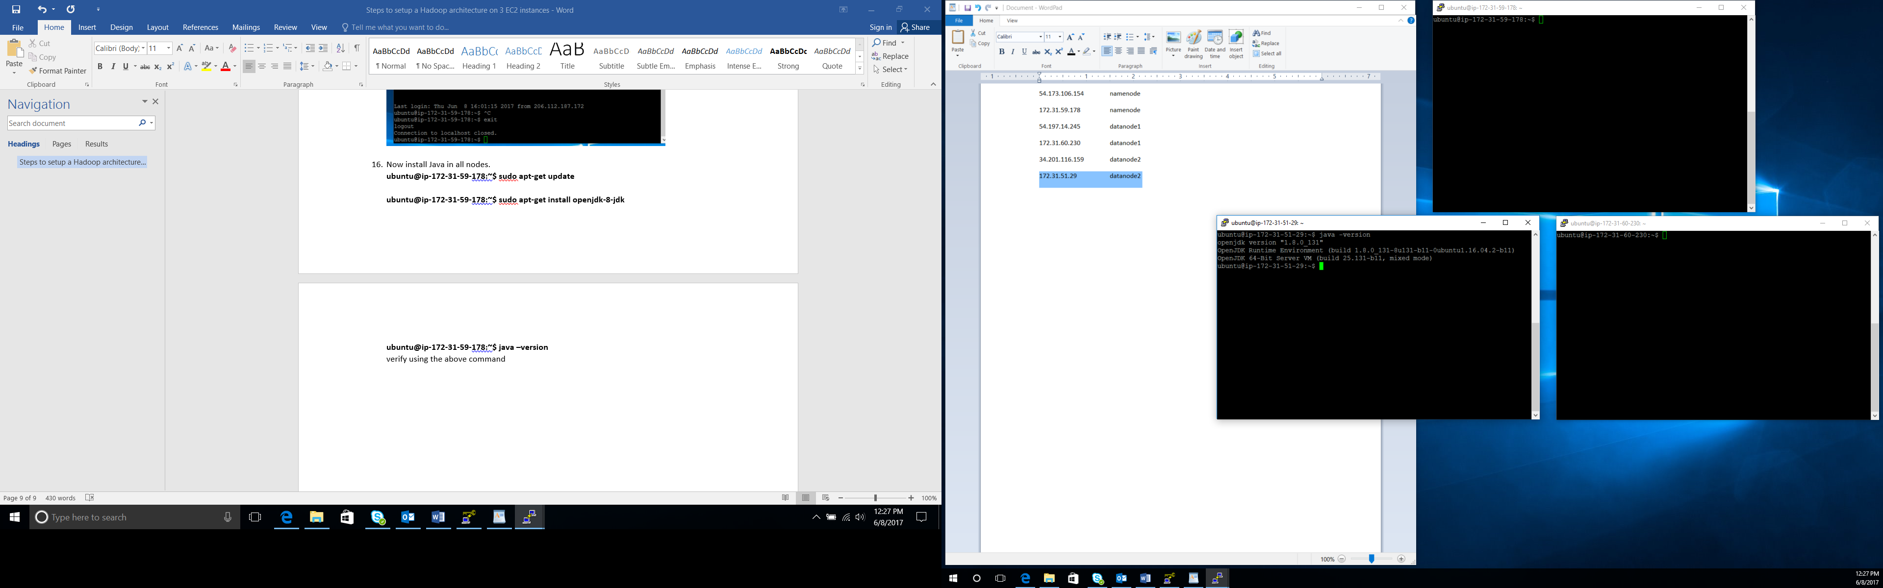

1. Download the Hadoop, unzip the file and move to the desired directory using the below commands in all the nodes.

**ubuntu@ip-172-31-59-178:~$ wget** [**http://apache.mirrors.tds.net/hadoop/common/hadoop-2.7.1/hadoop-2.7.1.tar.gz**](http://apache.mirrors.tds.net/hadoop/common/hadoop-2.7.1/hadoop-2.7.1.tar.gz)

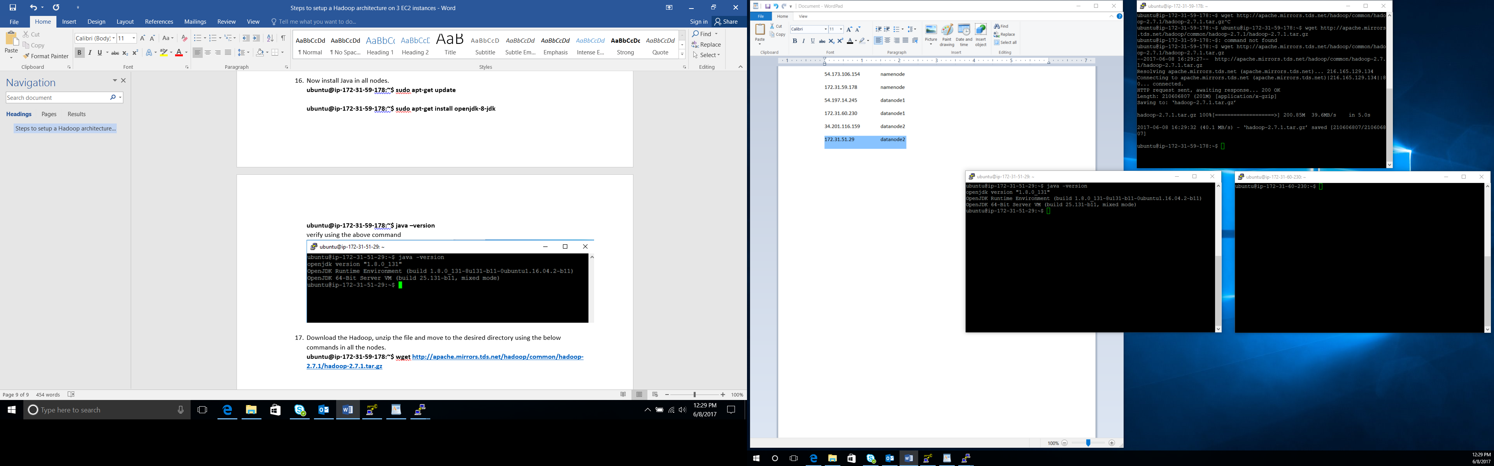

**Unzip the file: ubuntu@ip-172-31-59-178:~$ sudo tar zxvf hadoop-2.7.1.tar.gz**

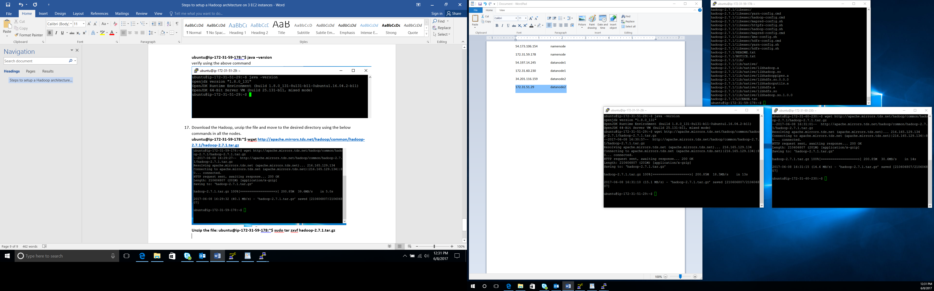

**Move to directory:**

**ubuntu@ip-172-31-59-178:~$ sudo mkdir /usr/local/hadoop**

**ubuntu@ip-172-31-59-178:~$ sudo mv hadoop-* /usr/local/hadoop/**

**ubuntu@ip-172-31-59-178:~$ cd /usr/local/hadoop/**

**ubuntu@ip-172-31-59-178:/usr/local/hadoop$ ls**

**hadoop-2.7.1 hadoop-2.7.1.tar.gz**

1. Set the environment variables

**export JAVA_HOME=/usr/lib/jvm/java-8-openjdk-amd64**

**export PATH=$PATH:$JAVA_HOME/bin**

**export HADOOP_HOME=/usr/local/hadoop/hadoop-2.7.1**

**export PATH=$PATH:$HADOOP_HOME/bin**

**export HADOOP_CONF_DIR=/usr/local/hadoop/hadoop-2.7.1/etc/hadoop**

in the end of the .profile file. Open the file using the below command

**ubuntu@ip-172-31-51-29:~$ sudo vi ~/.profile**

**ubuntu@ip-172-31-59-178:~$ source ~/.profile**

1. Configure the Hadoop file in all nodes.

Let’s start with $HADOOP_CONF_DIR/hadoop-env.sh

**sudo vi $HADOOP_CONF_DIR/hadoop-env.sh**

The only thing that needs changing is the location of JAVA_HOME in the file. Simply replace${JAVA_HOME} with /usr which is where Java was just previously installed.

$HADOOP_CONF_DIR/hadoop-env.sh:

# The java implementation to use.

**export JAVA_HOME=/usr/lib/jvm/java-8-openjdk-amd64**

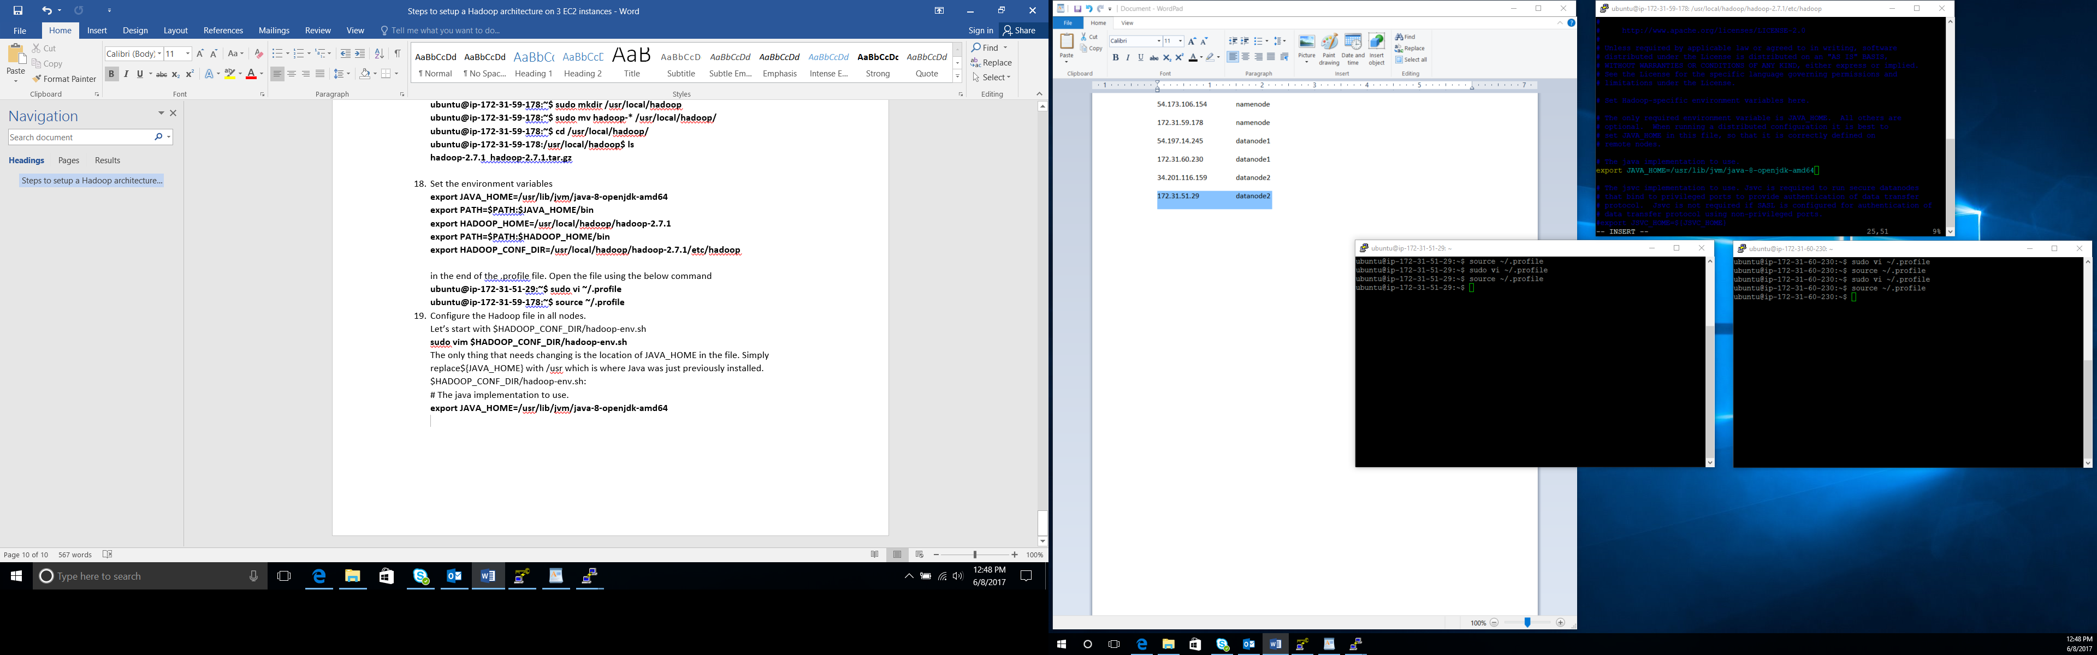

* Next configure the core-site.xml file

**ubuntu@ip-172-31-59-178:/usr/local/hadoop/hadoop-2.7.1/etc/hadoop$ sudo vi core-site.xml**

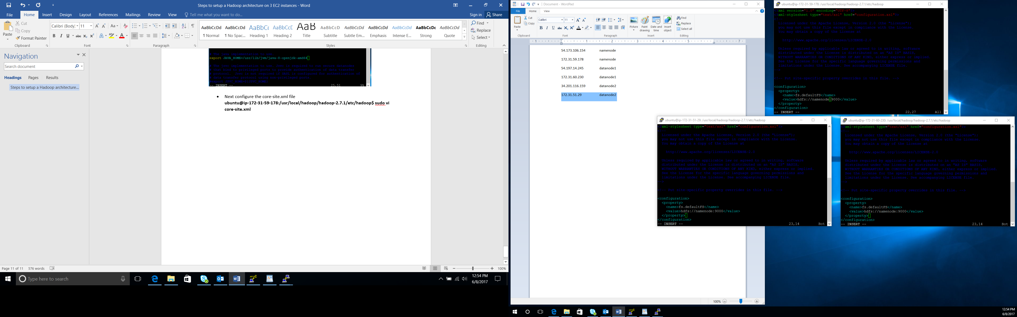

* Now configure the yarn-site.xml file

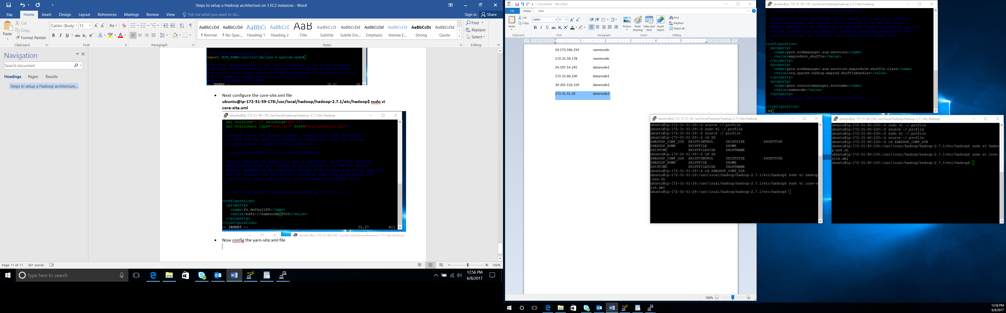

* Configure mapre-site.xml

**ubuntu@ip-172-31-59-178:/usr/local/hadoop/hadoop-2.7.1/etc/hadoop$ sudo cp $HADOOP_CONF_DIR/mapred-site.xml.template $HADOOP_CONF_DIR/mapred-site.xml**

**ubuntu@ip-172-31-59-178:/usr/local/hadoop/hadoop-2.7.1/etc/hadoop$ sudo vi mapred-site.xml**

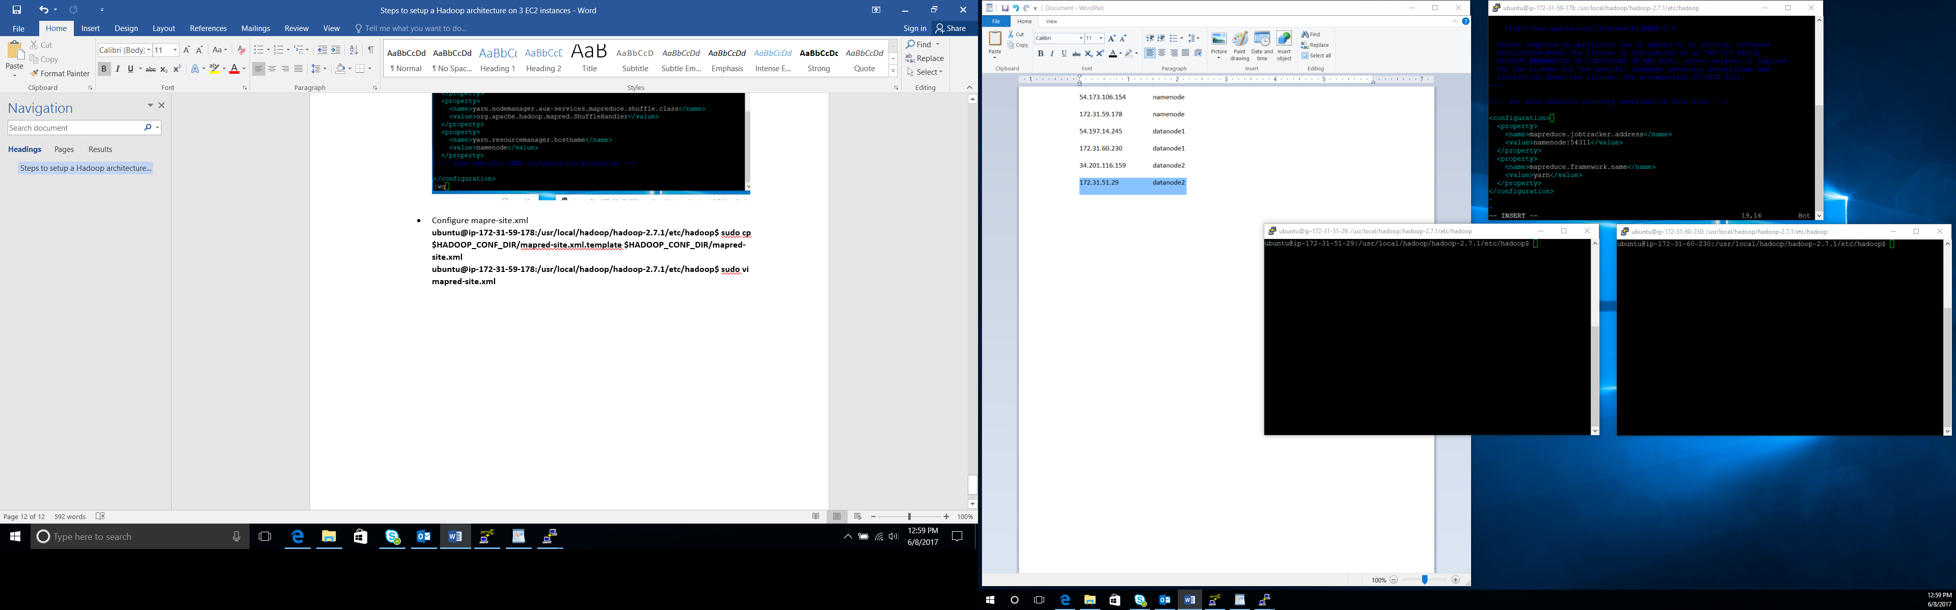

1. Now do configuration only on Namenode.

* Config hdfs-site.xml

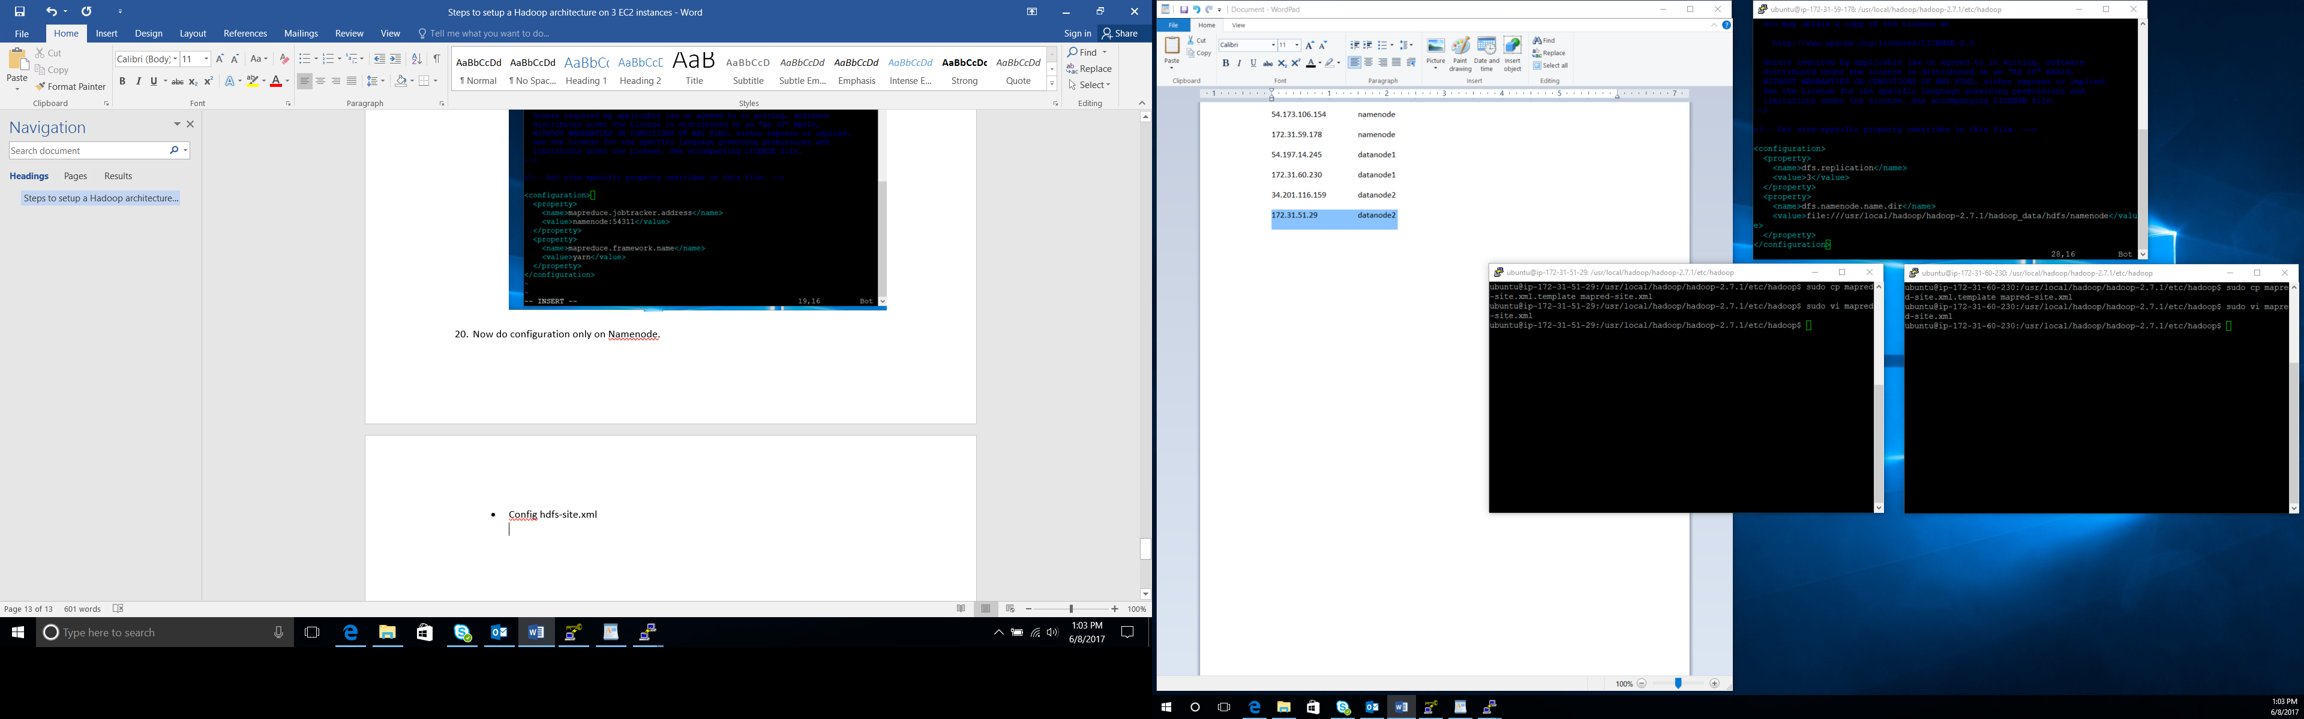

The current path where data on the NameNode will reside does not exist, so we’ll need to make this before starting HDFS.

**sudo mkdir -p $HADOOP_HOME/hadoop_data/hdfs/namenode**

**sudo chown -R ubuntu $HADOOP_HOME**

* Next we’ll need to add a masters file to the $HADOOP_CONF_DIR directory

namenode$

**sudo touch $HADOOP_CONF_DIR/masters**

Configure masters file

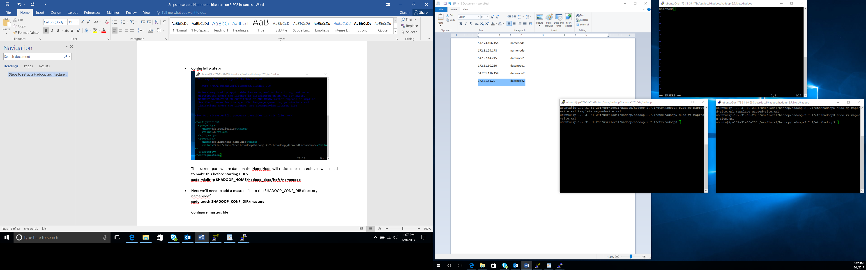

* Configure the slaves file

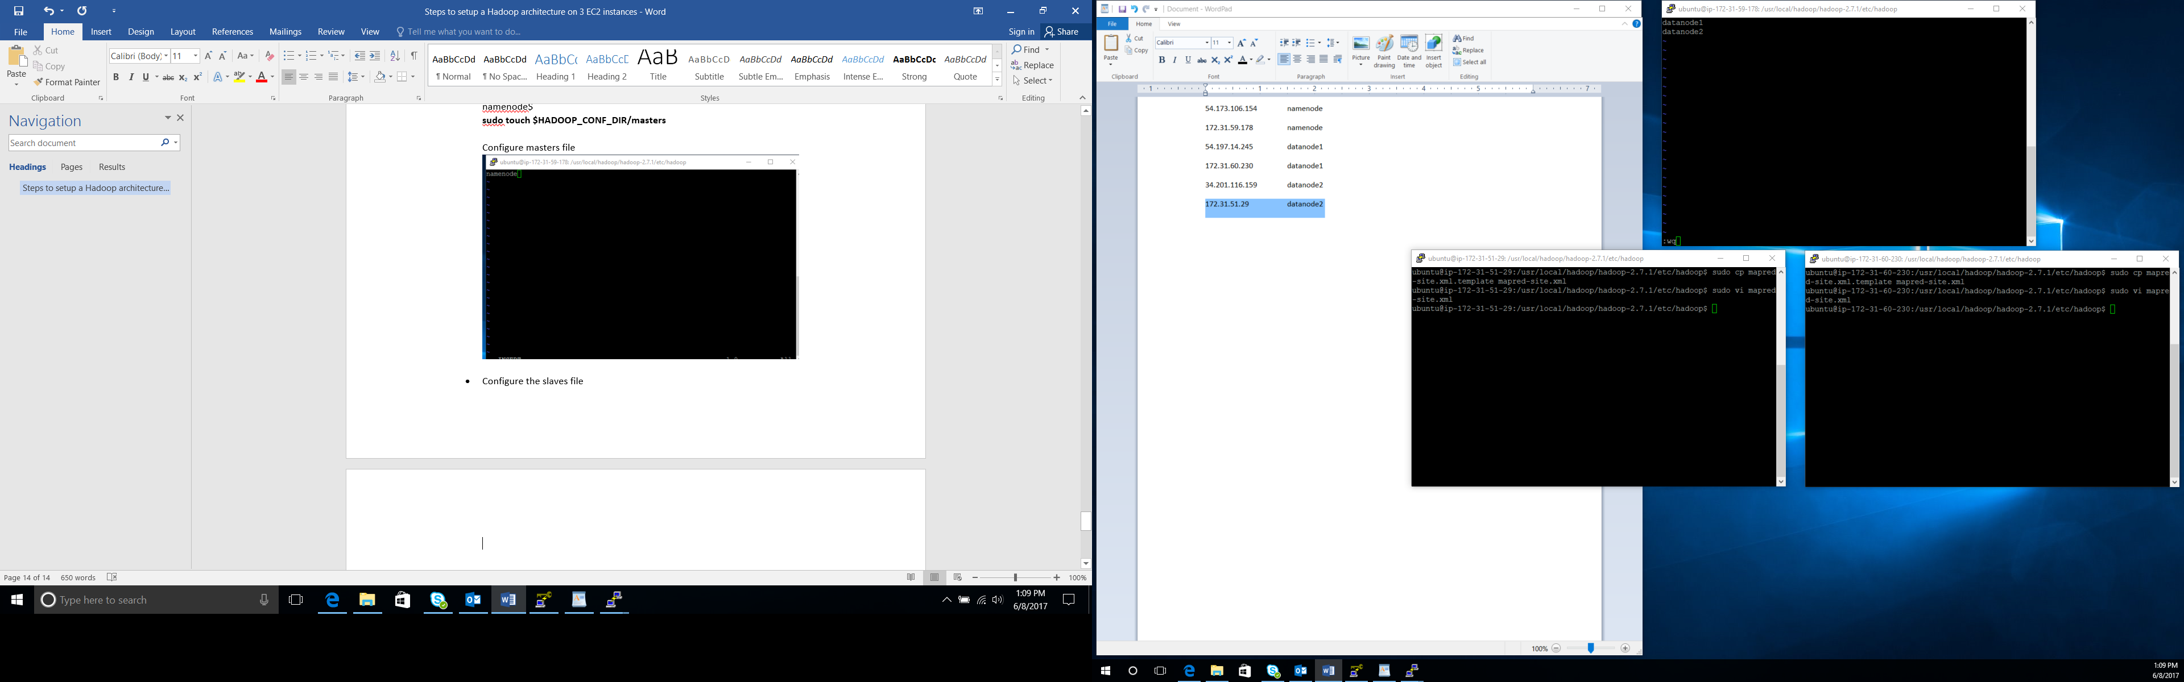

1. Now configure the DataNodes.

* Configure the hdfs-site.xml file

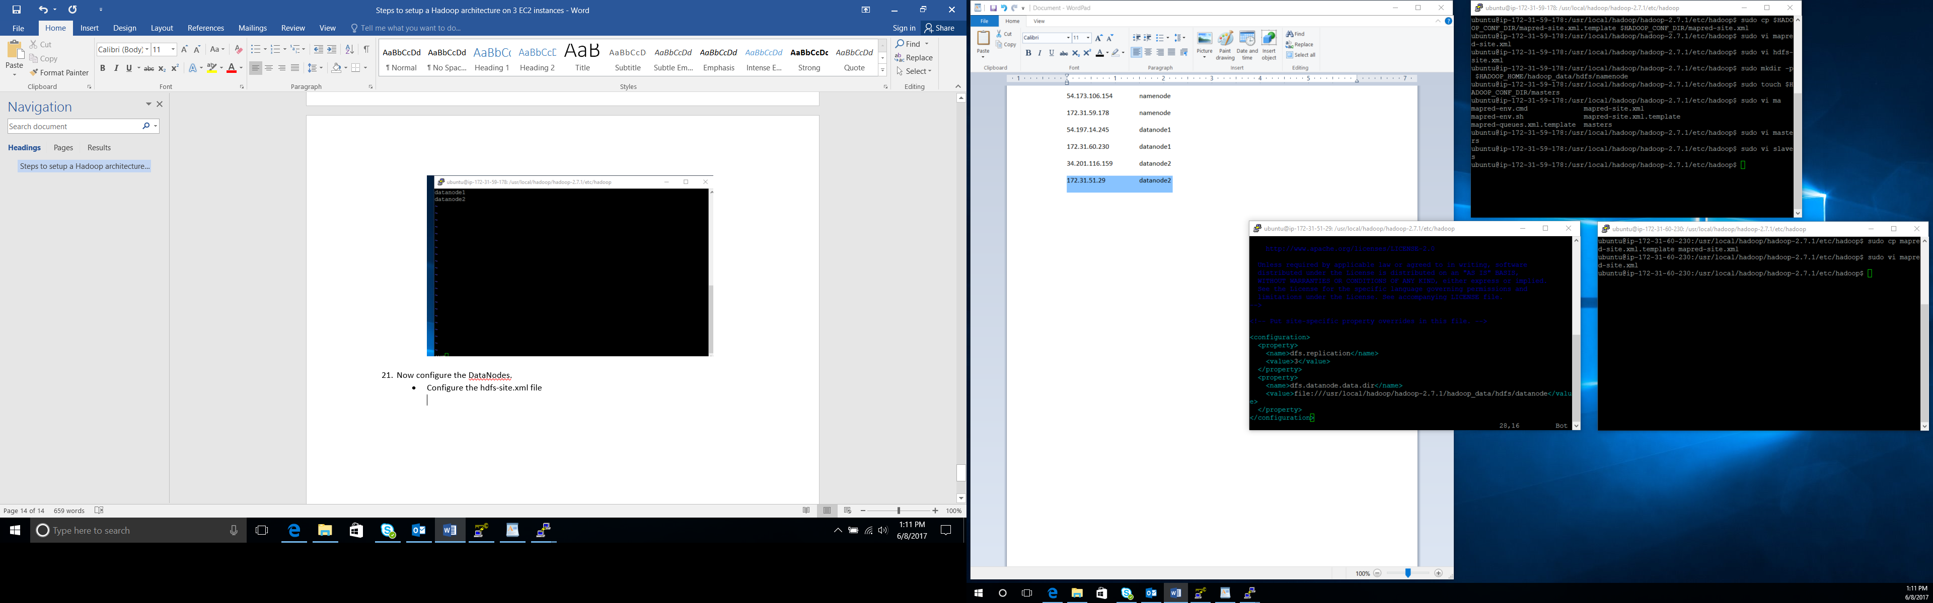

**sudo mkdir -p $HADOOP_HOME/hadoop_data/hdfs/datanode**

**sudo chown -R ubuntu $HADOOP_HOME**

1. Now the format the namenode using below command

**hdfs namenode –format**

Check the successful formatting

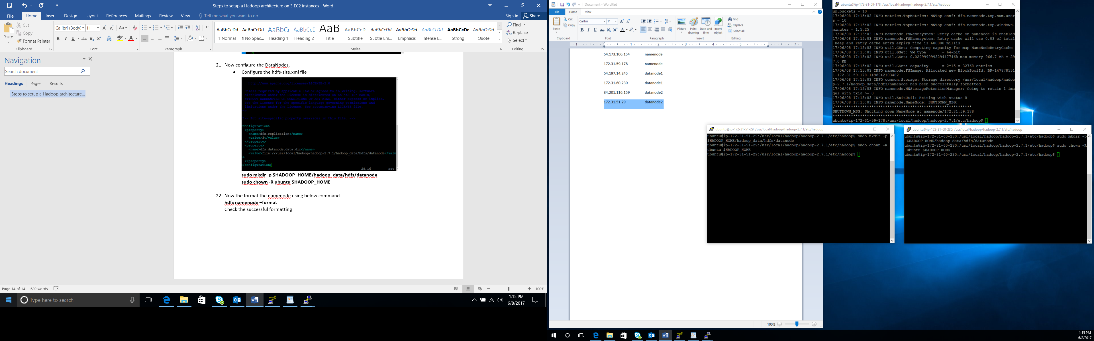

1. Now start the nodes one by one:

**$HADOOP_HOME/sbin/start-dfs.sh**

**$HADOOP_HOME/sbin/start-yarn.sh**

**$HADOOP_HOME/sbin/mr-jobhistory-daemon.sh start historyserver**

1. Verify the ouput by eexecuting jps:

